Directory Information Collector

Jason W. Turpin

Contents

Introduction 1

Collecting File Details 2

Collecting Folder Security Details 2

# Introduction

The Directory Information Collector is a simple application that collects file information or folder security details into comma-separated value formatted files.

It’s a useful tool for data archival and usage analysis as well as folder security audits.

It is best to run locally on the computer/server where the files/folders reside for performance reasons, but it works fine with external UNC paths as the source path for analysis.

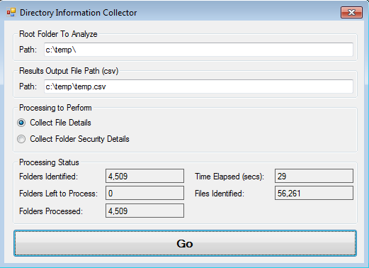

Figure 1 - Screenshot after Running File Details

# Collecting File Details

Just enter a path to scan, an output file path/name (CSV), select Collect File Details, and run.

The following information is collected:

* File Name
* Path
* Size in Bytes
* Creation Date
* Last Modified Date
* Last Access Date

# Collecting Folder Security Details

Just enter a path to scan, an output file path/name (CSV), select Collect Folder Security Details, and run.

The following information is collected:

* Path
* Identity Reference
* Inheritance Flags
  + https://msdn.microsoft.com/en-us/library/system.security.accesscontrol.inheritanceflags%28v=vs.110%29.aspx
* Is Inherited Indicator
* Propagation Flags
  + https://msdn.microsoft.com/en-us/library/system.security.accesscontrol.propagationflags%28v=vs.110%29.aspx
* Access Control Type
  + <https://msdn.microsoft.com/en-us/library/w4ds5h86%28v=vs.110%29.aspx>